Health Science Tools
Find Databases at: https://www.cuaa.edu/academics/library/collections/databases.html

Database | CINAHL COMPLETE | DYNAMED PLUS | MEDLINE COMPLETE
Diseases & Conditions
Diagnosis | * |  | *
Epidemiology | * |  | *
Treatments | * |  | *
Etiology | * |  | *
Patient Care
Clinical Assessment Tools
Contraindications
Drug Dosage Calculator
Drug Information
Evidence-based care | *
Patient education
Content Type
Exercise Sheets
Images
Video

*See page below for help with specific databases

In CINAHL COMPLETE click on “More” in the top bar and then search within the Quick Lessons.

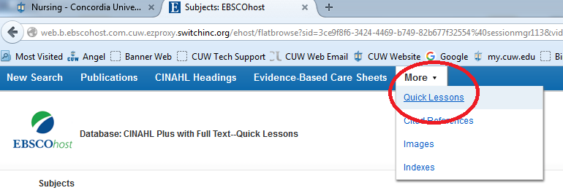
You may also search CINAHL Headings and then select Diagnosis, Epidemiology, Treatment or Etiology as a sub heading as part of your search.

In MEDLINE COMPLETE use the MeSH headings and then select Diagnosis, Epidemiology, Treatment or Etiology as sub headings as part of your search.

CINAHL COMPLETE has Evidence Based Care sheet are part its menu bar.
